Viscosity of Fluids

- Viscosity is the term we use to describe the “_______________” or “________________________” of a fluid and how well it flows
- Fluids that have a _______________________________ are said to be very “thick” and do not flow easily
Examples would be: Honey, Molasses, Tar
- Fluids that have a ________________________________ are said to be thinner and flow more easily
Examples would be: Water, Pop, Juice
What is Viscosity?
- Viscosity is a property of all fluids because it deals with the way the particles “_____________” around one another… it is the thickness of the fluid
- Both __________________and ___________________have some degree of viscosity, however, it is easier to comprehend viscosity in liquids because we can see and feel the “_____________________” of a fluid
- Viscosity of a fluid is a product of the ___________________ __________ between the particles that make up the fluid
- Fluids that have particles that are strongly attracted to each other _________________flow as easily
- In contrast, fluids whose particles are not as strongly attracted to each other ________________much more _____________
Strongly Attracted Particles (ex: syrup)
These particles are more strongly attracted to each other so they don’t flow as easily.
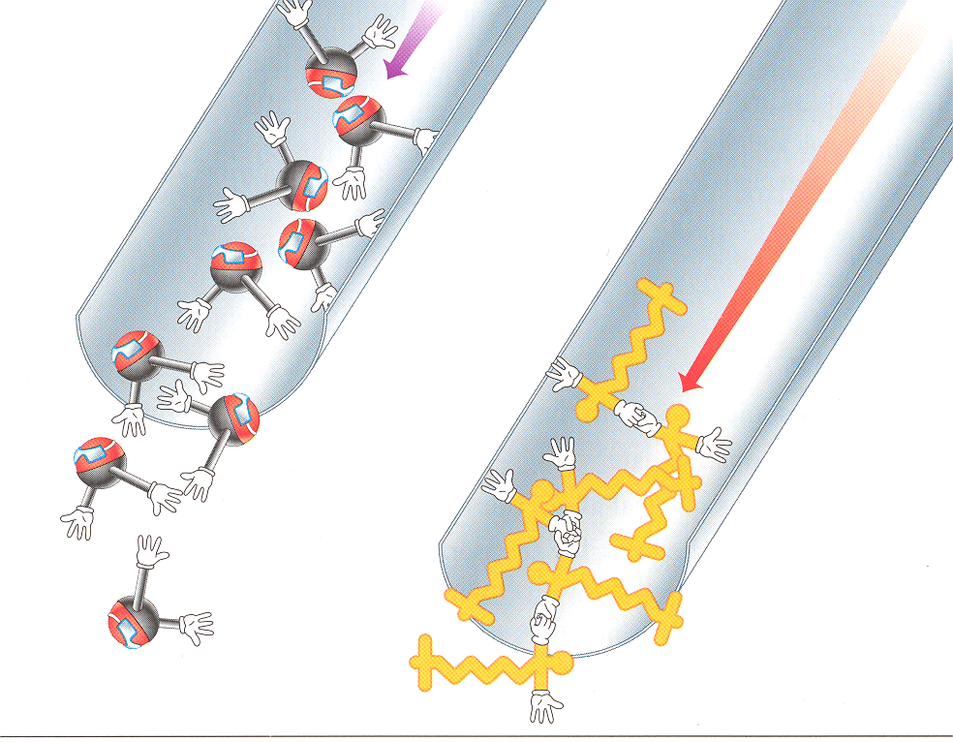
Practice Classifying:
Loosely Attracted Particles (ex: water)
These particles are not strongly attracted so they flow more easily.
Please list these fluids in order from the most viscous to the least viscous:
Salad Dressing Molasses Water
Syrup Cream

_________ _________ ___________ __________ _________

Flow Rate:
- Flow rate is the____________________ at which fluids can flow
- Highly viscous (______________) fluids have a very _________ flow rate
- Less viscous (_____________) fluids have a very ___________ flow rate

Factors Affecting Viscosity:
- ______________________ has the only major affect on viscosity in fluids
- Viscosity between gasses and liquids react ___________________ to changes in temperature

Temperature and Liquids:
- If we increase the temperature of a _______________we excite the particles within the liquid causing them to flow more easily
- Increasing temp. causes ______________________between the particles of a liquid to ___________________
THEREFORE
- The viscosity of a liquid _________________ as it is ______________, and _____________________ as it is __________________
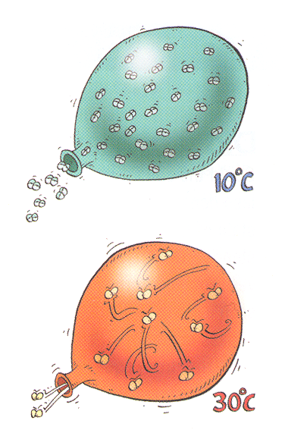
Temperature and Gases:
- If we increase the temperature of a _____________ we excite the particles within the gas causing them to move faster and ______________ more often
- The __________________________ between particles has the opposite effect… its actually _______________ ________________ between the particles and ___________________the flow rate
THEREFORE
- The viscosity of a gas _____________________ as it is _____________, and_________________ as it is _______________________

