The 6 Principles of Light
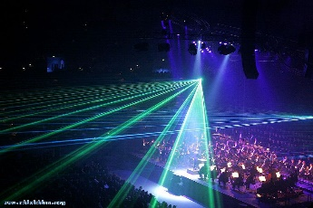
- 1. Light is a form of ____________________________________
- 2. Light travels in a ____________________________________

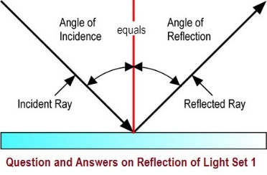
- 3. Light travels in a __________________________________ at 300,000 km/sec (and in some types of media at slower speeds.)
- 4. _____________________ – light reflects off objects (which makes them visible).
  - The angle of incidence is always equal to the angle of reflection
  - The incident ray, normal and reflected ray all lie in the same plane
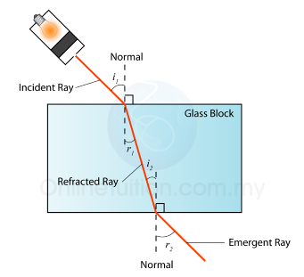
- 5. ______________________ is the bending of a wave when it enters a medium where its speed is different.
  - The Law of Refraction: As light travels at an angle from a less dense medium to a denser medium it refracts or bends the light ______________________ ________________________.
  - If light is traveling at an angle from a denser medium to a less dense medium it bends/refracts ____________________ _______________.
  - If a light is traveling straight into a medium, it ____________________ bend or refract.
- 6. __________________________ – each of the colours that make up _____________________ refract differently and so spread apart and become visible when passing through a ________________________________
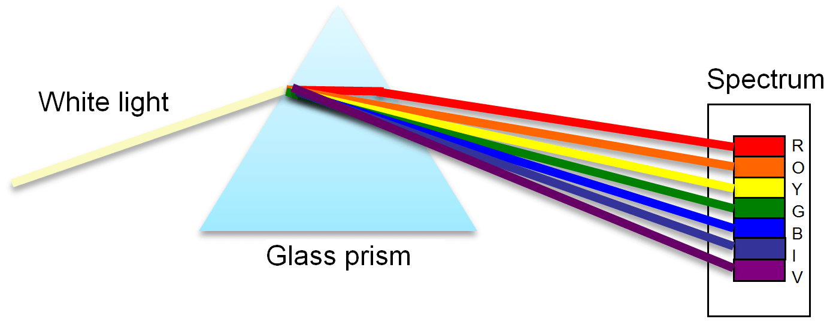
- Sir Isaac Newton discovered that dispersion happens when white light refracts through a prism. ______________________________________

Lenses and Mirrors Technology
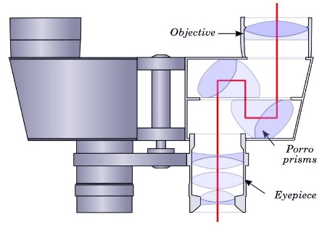
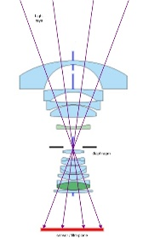
Microscopes: Cameras: Binoculars:
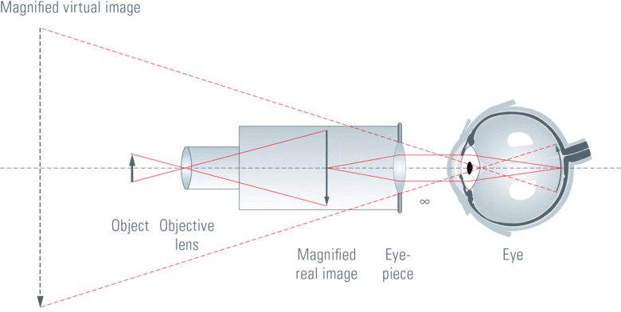

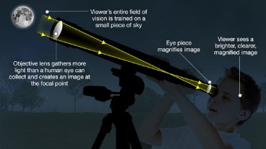
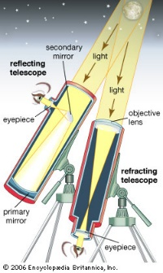
Teloscopes:
- 1. Refracting Telescopes – the first telescopes
  - Galileo and Kepler
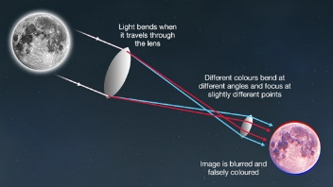
  - The lenses used in these telescopes were difficult to make at the time.
  - Problems with refracting: Image is falsely coloured and blurry

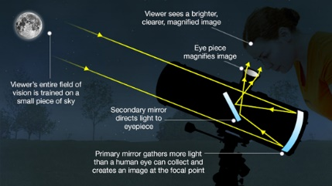
Reflecting Teloscopes
- Reflecting Teloscopes: Mirrors were much easier to make than lenses…and they didn’t refract the light and distort the colours.
- Isaac Newton invented this kind of telescope.
- Another benefit of using mirrors instead of lenses is that big mirrors are easier and cheaper to make than big lenses.
- Reflecting telescopes can be much much larger than refracting telescopes and therefore look deeper into space.
The Hubble Teloscope:
