Light is a form of energy that can be detected by the human eye.

Natural light sources come from nature.

Artificial light sources are man-made light sources.

We see luminous objects because they give off their own light.

We see nonluminous objects because their surfaces reflect light. In total darkness we see nothing.

The amount of energy a surface receives depends on the intensity of the light. The more intense the light, the more light can be absorbed.

Light travels in a straight line from its source
Until it It hits something and passes through, is reflected, scattered or absorbed

If light passes through a substance or object , it is called transparent.

If only some light passes through and the rest is scattered, it is called translucent. Objects cannot be clearly seen on the other side. Produces faint shadows.

If light is unable to pass through a substance or object , it is called opaque. Opaque materials block the passage of light and create shadows when light strikes them.

Pinhole camera – camera obscura – demonstrates how light travels in a straight line (and produces an inverted – upside down – image. Works similar to our eyes.
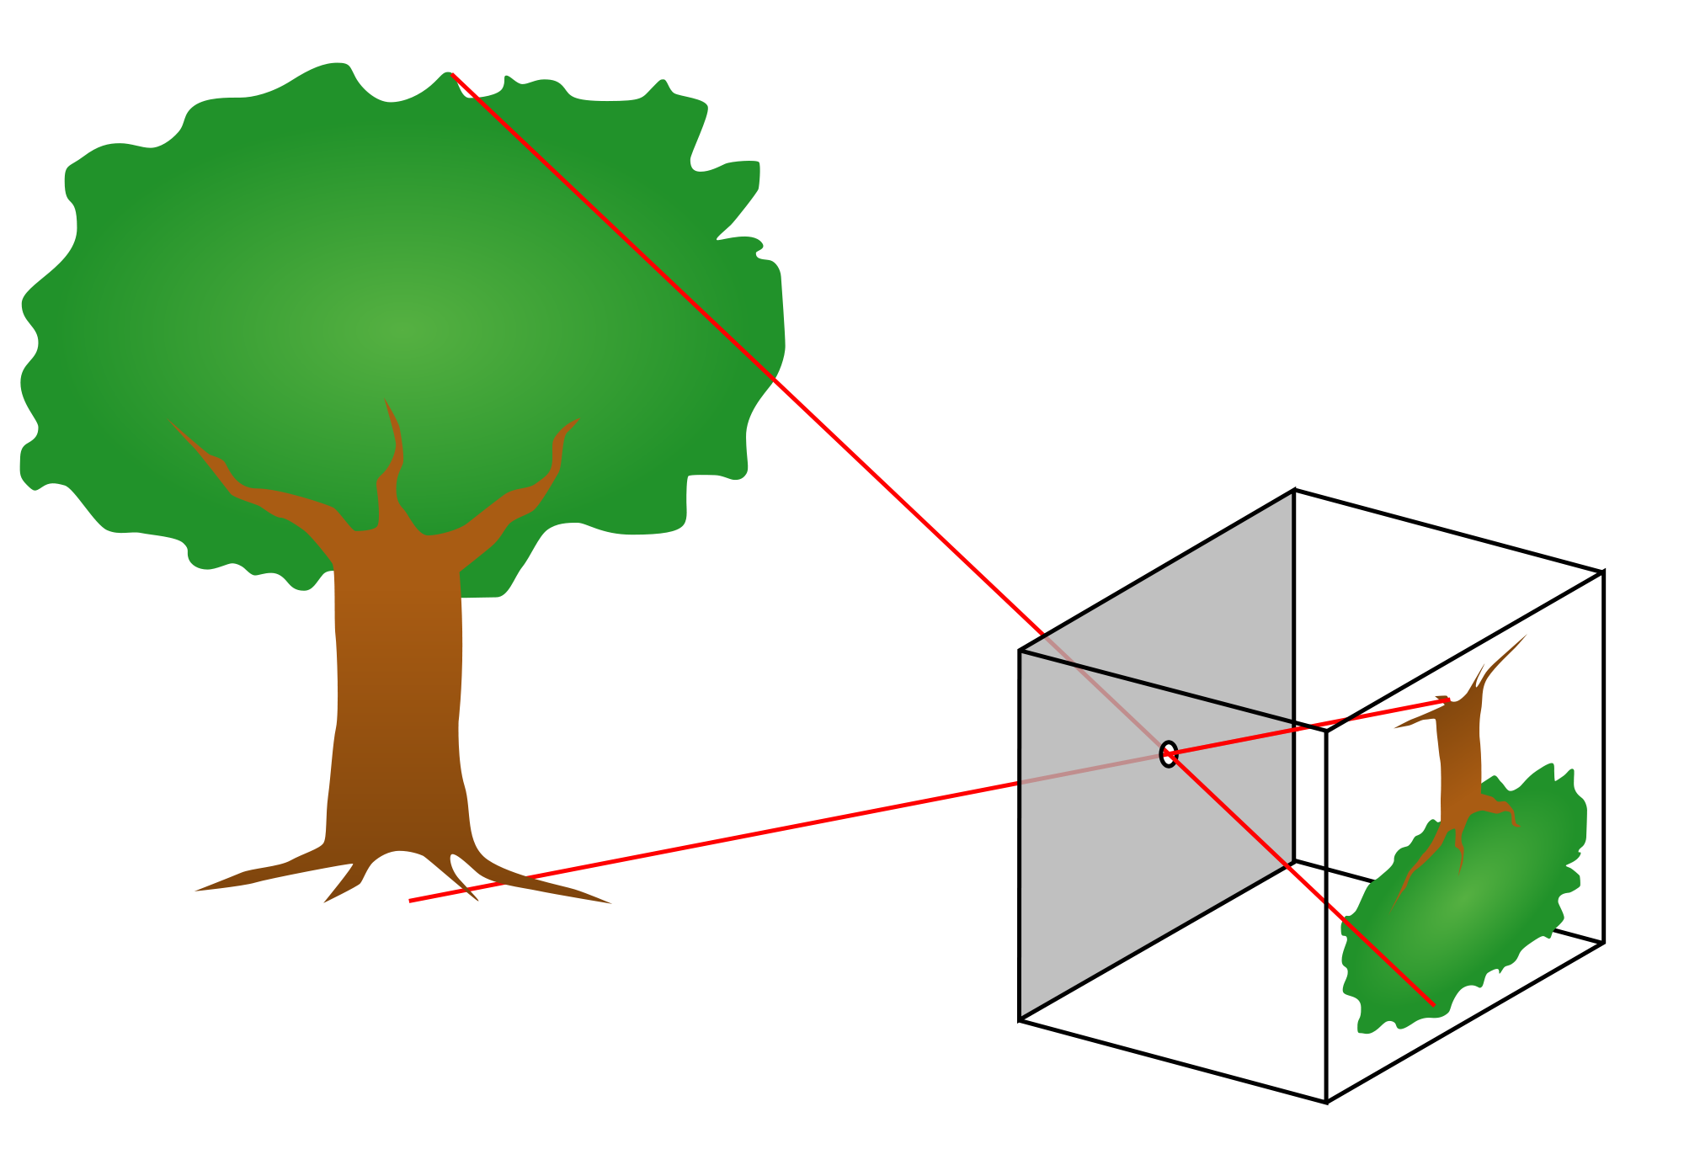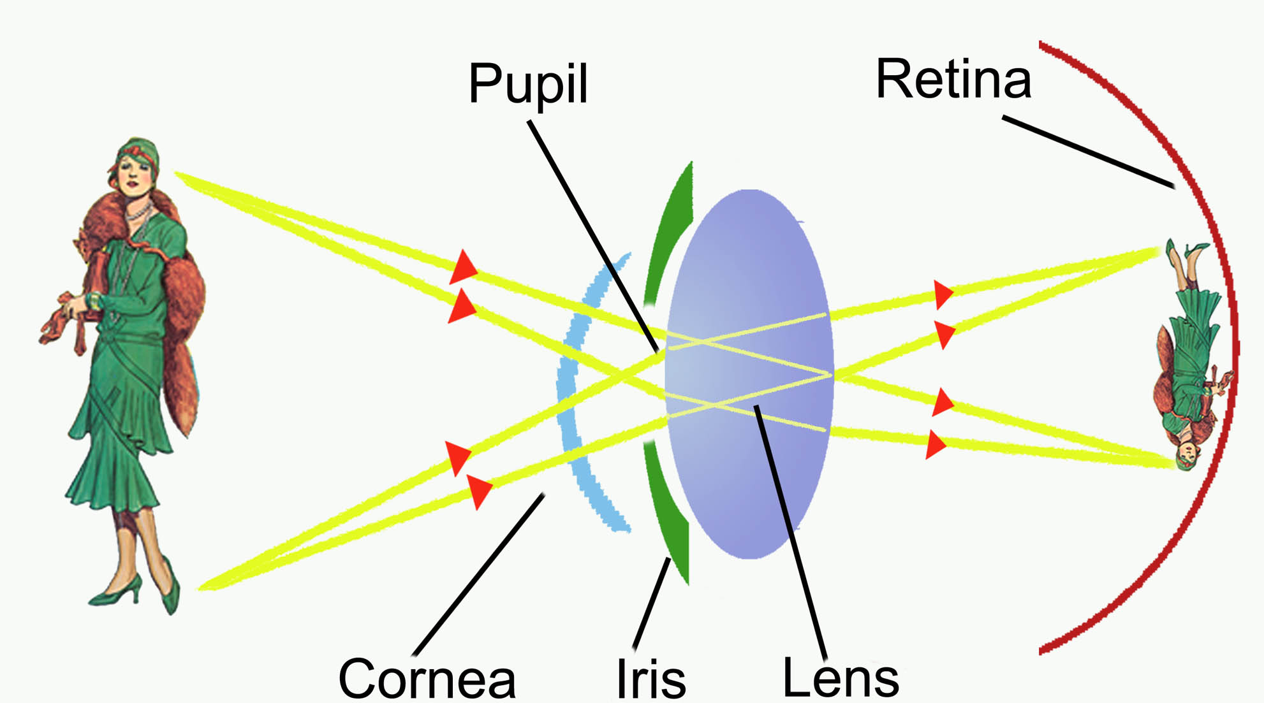

The angle of incidence always equals the angle of reflection
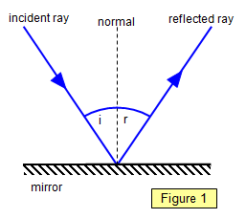
Periscopes

The reflection of light off an irregular surface is called diffuse reflection.
Irregular surfaces scatter the reflected light and you can’t see an image.

The reflection of light off a smooth, shiny surface is called regular reflection.
When light reflects in this way we can see an image (this happens off mirrors and shiny surfaces).

Convex mirrors – always produce a smaller, up-right image.

Concave mirrors – produces a different image depending on where your object is placed.
1. If far away, it’s upside down and smaller.
2. If close, it’s up-right and bigger

- Refraction – the “bending” of light as it passes from one material into another.
- Light bends because it travels at different speeds in different materials.
- It travels faster when there are less particles in the way (less dense)

- The Law of Refraction states that:
- when light travels from one medium, to a more dense medium, the light will slow down and bend toward the normal,…
- …and when it exits the denser medium into a less dense medium, it will speed up and bend away from the normal.

