Sources of Light
First Basic Principle of Light
Light is a form of __________________________ and when it reaches a surface it can be___________________ and ___________________________________ into other forms of energy
- Solar cells change light into ___________________________
- Trees change sunlight into ___________________________ energy
Sources of Light
1. Incandescent Sources
An object is heated to a very _________________________________________until it emits visible light.
- Ex: _______________________ and ___________________________
2. Fluorescent Sources
A source that produces _______________________________ light by the ionization of mercury within a phosphor coated tube.
- ____________________________ light bulbs
3. Phosphorescent Sources
The emission of light following_________________ to and removal of a source of __________________
- Main difference between phosphorescent and fluorescent is – particles in a fluorescent source release their light immediately.
4. Chemiluminescent Sources
The ___________________________________________ that emits visible light and not involving heat
- Ex: __________________________
5. Bioluminescent Sources
An organism that relies on a ______________________________ within their ________to produce light
- Ex: Jelly fish and Squid
The First Basic Principle of light- Revisited
- ‘Light is a form of energy’ When light reaches a surface, it can be absorbed and transformed into other types of energy.
… into electrical energy … into thermal energy … into chemical energy
- Solar cells change Cameras change light into Trees convert light energy into food
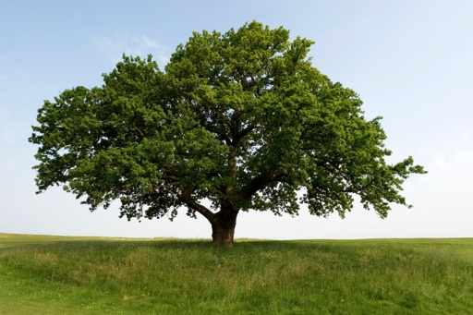
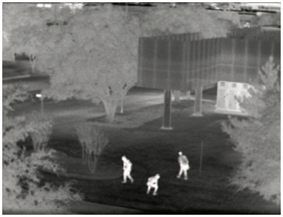
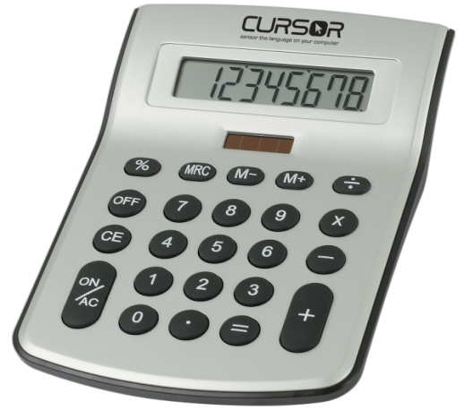
light into electricity thermal images (chemical energy)
- The amount of energy a surface receives depends on the ________________________________ of the light. The more intense the light, the more light can be absorbed.
Intensity Demo:
- Why, if light travels in a straight line, does the page of the book appear brighter the closer it is to the flashlight?
_____________________________________________________________________________________
_____________________________________________________________________________________
_____________________________________________________________________________________
_____________________________________________________________________________________
The Second Basic Principle of Light:
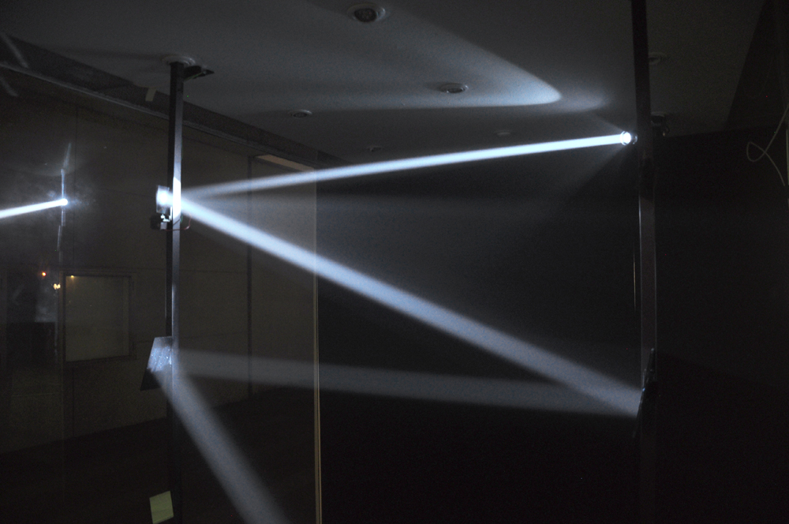
- Light travels in a __________________________ from its _______________________
- Light will continue to travel in a straight line until it____________ something.
- The light becomes ______________________________as it travels farther away, which can be seen in this picture.
Laser Pointer and Dust:
- Why or how you see the laser going across the room?
_____________________________________________________________________________________
_____________________________________________________________________________________
_____________________________________________________________________________________
_____________________________________________________________________________________
- So light keeps on going….forever! Unless it hits something.
- What happens when light hits something? Besides reflecting and absorbing?
_____________________________________________________________________________________
_____________________________________________________________________________________
_____________________________________________________________________________________
_____________________________________________________________________________________

