Cells: An Introduction
Characteristics of all Cells:
- A surrounding_____________________________

- ___________________– cell contents in thick fluid

- ________________________ – structures for cell function

- Control center with___________________

Two Types of Cells: _____________________________; _____________________________

Prokaryotic Cells:
- First cell type on_________________________
- Cell type of _____________________________and _____________________________
- No membrane bound _______________________________
- _____________________________ = region of ____________ concentration
- ___________________ not bound by membranes
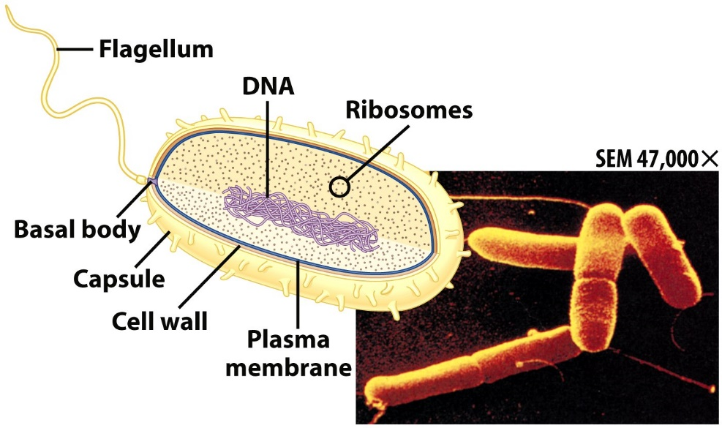
Eukaryotic Cells:

- _____________________ bound by ______________________

- Include _________________________,_____________________, ______________, and _________________

- Possess many ___________________________

