Reflection Notes
- The reflection of light off a smooth, shiny surface is called ______________________________.
- When light reflects in this way we can see an image (this happens off mirrors and shiny surfaces).
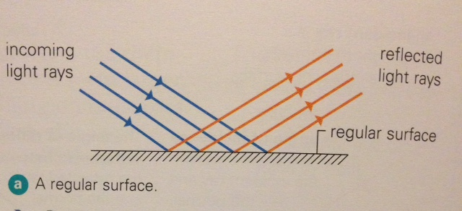
- But most surfaces are not regular.
- The reflection of light off an irregular surface is called __________________________________.
- Irregular surfaces ________________________ the reflected light and you can’t see an image.
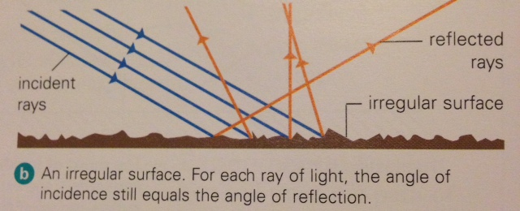
- You can’t see images in cardboard or broccoli for example.

- What happens when you have a smooth, shiny surface but it’s not flat? What if it’s curved? Do they make an image? Or do they scatter light?
__________________________________________________________________________________
__________________________________________________________________________________
__________________________________________________________________________________
Convex Mirrors
- A convex mirror produces a small image standing _____________________________________.
- It reflects back a _________________________________________ than a concave mirror does.
- Convex mirrors are used for security purposes in stores.
Concave Mirrors:
- A concave mirror can reflect in two different ways:
- if the object is ________________________, the mirror will make it ______________________ and _____________________________________.
- if the object is ___________________________, the mirror will make it appear ______________ and ___________________________________.
- Concave mirrors are used for shaving

