Notes- Lenses
- Once we understood how refraction occurred, lenses were created to refract light in specific ways.
- Here are a few of the different types of lenses that exist:

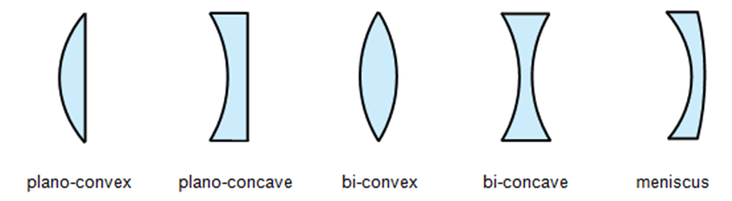
- 2) 3) 4) 5)

- Each of the different kinds of lenses refract (bend) light in a unique way.
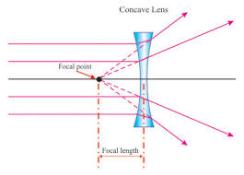
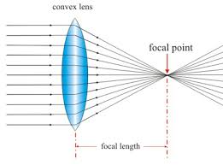
  - E.g. A convex lens
  - A concave lens

- Your eyes have lenses. They refract the light so it focuses the light on the back of your eye.
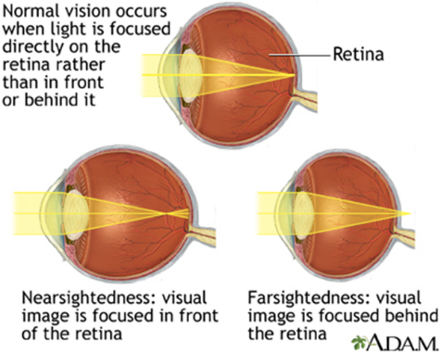
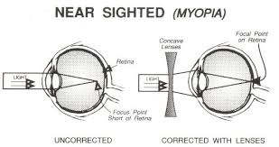
- We use glasses to refract the light and make it focus where it’s supposed to be
