Microscope Labeling Name _______________
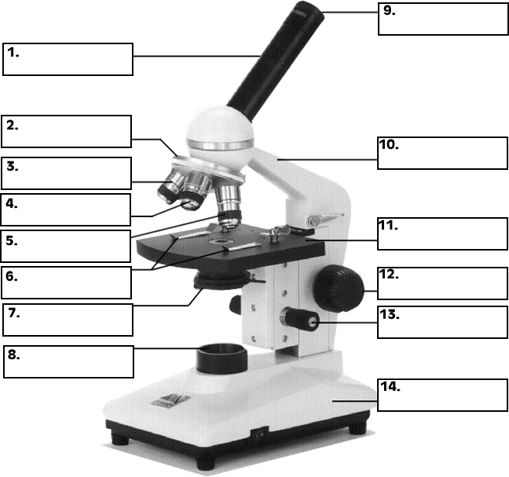
Word bank – objective (can be used 3 times) stage base arm eye piece fine adjustment knob
Revolving nose piece diaphragm stage clips body tube light source coarse adjustment knob
15. When focusing a specimen, you should always start with the _____________ objective.
16. The type of microscope used in most science classes is the compound microscope.
17 and 18. You should carry the microscope by the ____________ and the ______________.
19 and 20. A microscope has an ocular objective of 10x and a high power objective of 50x, what is the microscope's total magnification? ______________

