Mass and Weight
Mass:
- The amount of ____________________ in an object
- ________________________________ based on where you are in the solar system or universe
- Given in _____________________________________________________
Weight:
- the _____________________ on an object due to_________________
- Depends/______________________ based on what the _____________________ _______________ is
- Given in units called ____________________________
- ______________________________________ = (mass) x (acceleration of gravity)
Weight vs Mass:
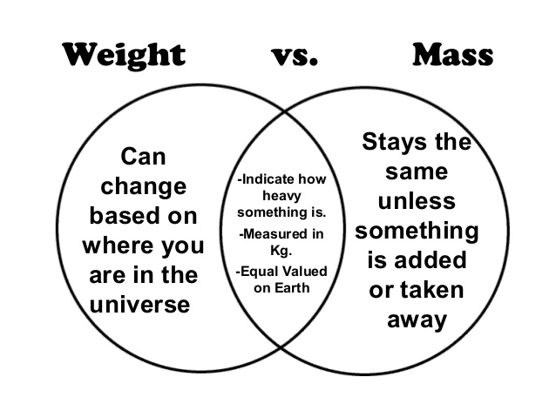
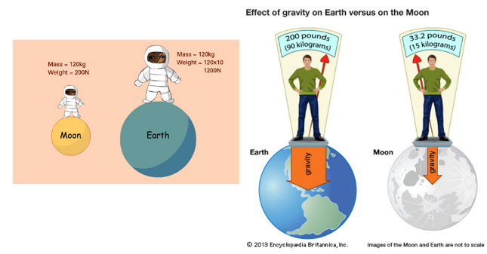

Mass vs Weight Relationship:
- Mass and Weight are_________________________________ on Earth
- For every ___________of mass, there is ___________________ of gravitational force (ON EARTH) pulling down on the object
- The equation for calculating the weight of an object on Earth is: __________________________
- So, a 100kg human would have a weight of _______________________
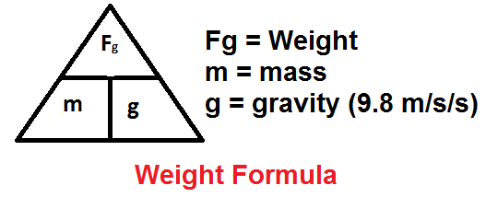
- W=100kg*9.8N/kg

Mass and Weight Examples:
 | Earth | Moon | Jupiter
Mass | 100kg | 100kg | 100kg
Gravitational force
Weight
