Density Continued
Ways to Change Density:
- Change_______________________ AND Keep _________________ _______________________
Increase the mass ___________________ density
Decrease the mass __________________ in density
Which container has more density? A or B
b) Change________________________ AND Keep _____________________ ___________________
Increase the _____________ decrease ____________________
_______________ the volume _____________________ density
Which container has more density? A or B
What 2 ways will INCREASE the density?
a) ______________________________________________________________________

________________________________________________________________________

b) ______________________________________________________________________

________________________________________________________________________

Liquid Layers:
- If you pour together liquids that ___________ ________ and have different densities, they will form liquid layers.
  - The liquid with the ________________________ density will be on the bottom.
  - The liquid with the________________________ density will be on the top.
- Objects or substances with ____________ density will sink below objects or substances with______________ density
  - Which do you think is MORE dense, Water or Oil???
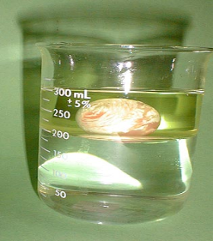
Water, Oil and a Superball:
The oil is ____________________ dense than the water, so it’s on top. The superball is less dense than ______________, but more dense than ___________, so it sinks to the bottom of the oil layer, yet floats on the top of the water layer.
If you have 2 or more substances, the ____________________ dense substance will be on bottom The _________________________ dense substance will be on top

Practice:
- The density of five liquids are measured as follows:

  - Liquid 1: 1.0 g/mL
  - Liquid 2: 1.38 g/mL
  - Liquid 3: 0.77 g/mL
  - Liquid 4: 2.95 g/mL
  - Liquid 5: 0.056 g/mL
Draw a picture of all 5 liquids in a test tube how they would layer according to density.
2) Check out this picture.
a) Which layer has the highest density?_______________________________________________
b) Which layer has the lowest density?________________________________________________
c) Imagine that the liquids have the following densities:
  - 10g/cm³. 3g/cm³.
  - 6g/cm³. 5g/cm³.
Which density would go with which layer?
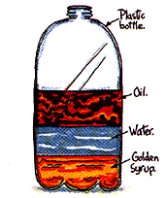
3) Liquid Layers:
- Which liquid has the highest density?
- Which liquid has the lowest density?
- Which liquid has the middle density?

4) Imagine that the liquids on the right have the following densities:
  - 15g/cm³ 10g/cm³
  - 3g/cm³ 9g/cm³
  - 7g/cm³ 12g/cm³
Match the colors to the correct densities.

