Buoyancy & Displacement Name:
Date:
Total out of /24 % Pattern:

- Archimedes Principle states that… ____________________________________________________

_________________________________________________________________________________
/ 1

_________________________________________________________________________________

1500 g
Bowl
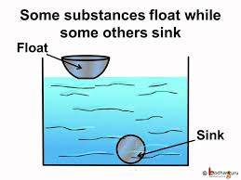
- In the diagram to the right, both the aluminum bowl, and the aluminum bearing have the exact same mass of 1500 g. Use Archimedes Principle to explain why the bowl floats, and the bearing sinks… be specific with masses if you can.

/ 3
1500 g
Bearing

- Below is a table to lays out the sizes of weights that were submerged into a beaker of water as well as what the weight was after it was submerged in water. Please fill in the last two columns by first calculating how much weight was “taken off” by the buoyant force of that water as well as how much water was displaced by the different weights. (Note – 1 gram of water equals 1 ml)
/ 8
/ 3
Mass of Weight Unsubmerged (g) | Mass on spring scale after the weight was submerged (g) | How much weight was “taken off” (g) | How much water was displaced by the weight (ml)
150 g | 135 g
350 g | 315 g
400 g | 360 g
550 g | 495 g

- Use the diagram below to decide how much water was displaced by the weight (in lb) after it was submerged in beaker.
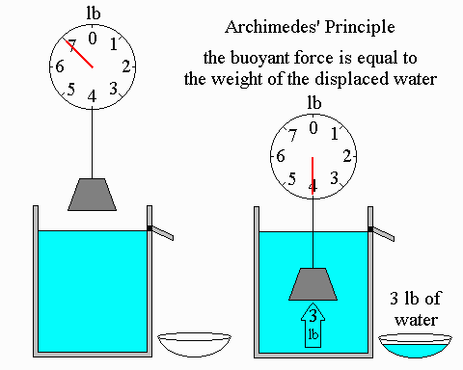
How much mass was “taken off” after the weight was submerged? _______

What was the buoyant force? _______
/ 3

Based on your above two answers, what mass of liquid had to be displaced into the small bowl on the side? _______

- Use the diagram below to decide how much water was displaced by the weight (in Kg) after it was submerged in the beaker.
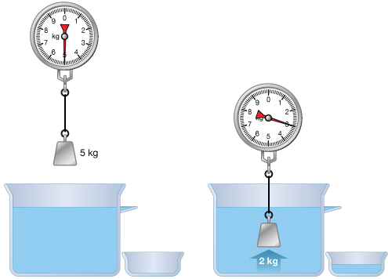

How much mass was “taken off” after the weight was submerged? _______

/ 3
What was the buoyant force? _______

Based on your above two answers, what mass of liquid had to be displaced into the small bowl on the side? _______

- Use the diagram below to decide how much water was displaced by the weight (in Kg) after it was submerged in the beaker.
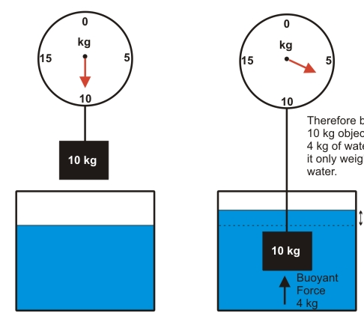

How much mass was “taken off” after the weight was submerged? _______

/ 3
What was the buoyant force? _______

Based on your above two answers, what mass of liquid had to be displaced and raise the water level?
_______

- a) If you and a boat have a combined mass of 2,750 kg, then what is the minimum mass of water that must be displaced by the boat in order for it to stay afloat? ______________
/ 1

- If you and a pool toy have a combined mass of 65 kg, then what is the minimum mass of water that must be displaced by the pool toy in order for you to stay afloat? _____________
/ 1

- If you have model jeep with a mass of 785 g, then what is the minimum mass of water that must be displaced by the jeep in order to stay afloat? ______________
/ 1

