Light: Introduction

What is light?
- Light is not something you can _______________or ______________
- But you can see light and it can __________ ____________ in different ways.
- E.g. heat lamps keep fries warm at McDs
- Does it have any mass?
- So, light has no ___________________, so it can’t be ______________
- Light is a form of _________________that can be __________________ by the human eye.

Blackout Room:
- We can see the __________________because of the light that comes directly into our eye.
- But how do we see other things in the room?
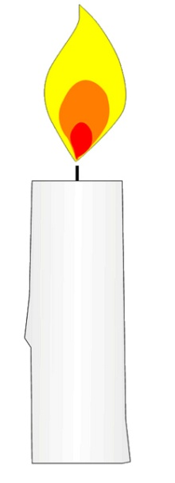
- ______________________________Without light we were unable to see anything – but with one candle, light reflected off every object in the room and we could see everything!

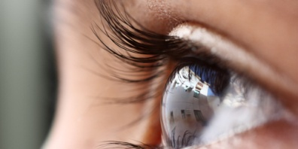

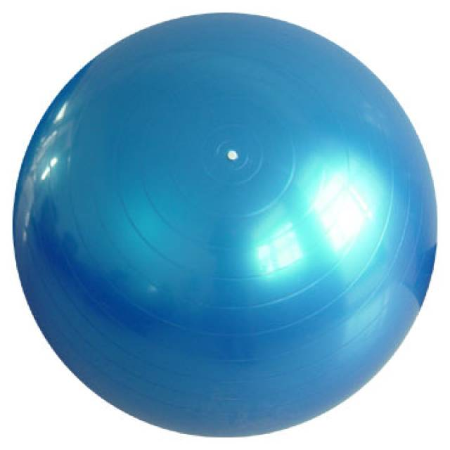

Some of the light is ________________________is transformed into ______________________________________
So where does light come from?
- _______________________light sources come from ________________
- _______________________ight sources are ___________ light sources.
- We see _____________________________________because they ____
  - ______________________________________
- We see ________________________________ because their surfaces ____________________________.
- In total darkness we see nothing

