Laws of Reflection NOTES
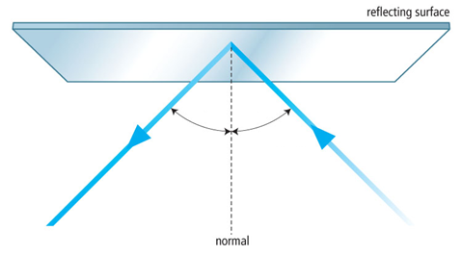

- In order for something to act as a mirror and reflect an image, it has to be _______________________________
- Light rays hit a mirror and bounce off (reflect off)
- The incoming ray is called the ____________________________________
- The outgoing ray is called the ____________________________________
- The incident ray and the reflected ray on either side of a line called the _____________________________
- The normal is an imaginary line that is ____________________________________ to the boundary
- The angle made by the incident ray and the normal is called the _______________________________________
- The angle made by the reflected ray and the normal is called the ______________________________________
- ____________ is always equal to ____________
- This is called the ________________________________________________________
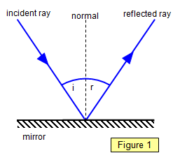
- When light strikes a reflective surface, it bounces off (reflects) the surface.
- A light ray that strikes a surface is called an _______________________
- The light that is reflected from a surface is called a _________________ _____________
- The line half way between the incident ray and the reflected ray is called the _____________________________________
- The angle between the incident ray and normal is called the__________ _________________________________________________
- The angle between the reflected ray and the normal is called the ______________________________________
- The __________________________________ is the spot where the incident ray strikes the reflecting surface.

