Name: __________________________Class:_____________Date:________________

Improving Physical Activity at EVJH

Outcome 9.22 : examine how design and infrastructure of the school can enhance physical activity among youth.

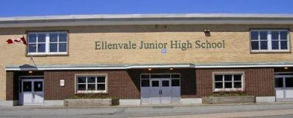
TASK: Decide on a realistic improvement that you would like to see made to your school which promotes physical activity.

Create a proposal for the Halifax Regional Education Centre and your principal.

Your proposal can be in any of the following forms:
- Poster - Song
- Google Slide presentation - Video
- Brochure - Poem
- Advertisement - Book

Requirements
No matter which proposal format you choose, you must include the following:

- What: what is the improvement you are suggesting?

- Why: why is it important this improvement happens? Give at least 5 benefits here.

- Where: specifically where will this be at the school? (ex: classroom, soccer field, etc).

- Who: (Grade level, gender, etc). Complete a survey to find out WHO agree with your idea and will use it. Include the results in your project. If many students say they’ll use it, there is a higher chance it’ll actually happen. who CAN and WILL use this improvement? How do you know (did you ask other students here at EVJH)?

- How: - how will this improvement happen? (think about cost, approval by the principal, parents, school board, space, etc)
- how will it increase physical activity at EVJH?

- When: - when should this improvement take place?
- when can people use this improvement during the day?

- Creative and use of colour or different scenes if creating video

- Professional/correct spelling or speech

- Images or pictures that relate to your proposal

- A professional appearance or delivery

See rubric on backside...

Rubric
While completing this project follow the requirements above and this rubric to determine your mark.

1 | 1+ | 2 | 2+ | 3 | 3+ | 4
0-2 of the requirements are in the proposal.  Didn’t use enough detail. | 2-4 of the requirements are in the proposal.  Didn’t use enough detail. | 4-5 of the requirements are in the proposal.  Should've used more detail. | 5-6 of the requirements are in the proposal. Should've used more detail. | 6-8 of the requirements are in the proposal. Used good detail. | 8-10 of the requirements are in the proposal. Used good detail. | All 10 of the requirements are in the proposal. Used excellent detail.

