Fluids: Particle Theory of Matter & States of Matter

Introduction:
- __________________ – anything that takes up space _______ has mass.
- It’s ___________________________
Examples:
1)

2)

3)

Particle Theory of Matter:
- Everything is made of _________________ (_______ or ___________)
- These particles are always_________________ (the energy (________) determines the speed)
- All particles in a _____________substance are the_____________ – different substances are made of _______________ particles
- There is _________________between the particles
- The particles in a substance are ___________________to one another – the strength of the attraction depends on the type of particles.

States of Matter:
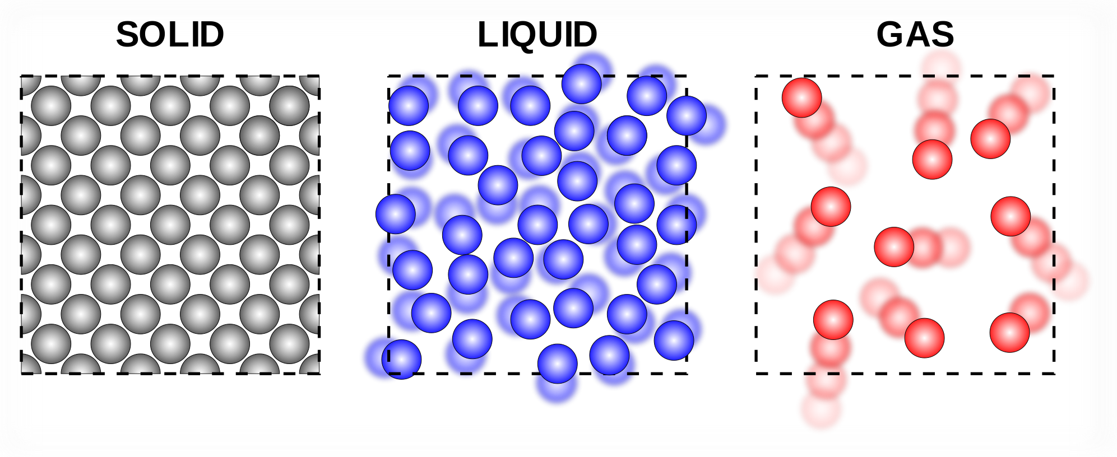

 | Solid | Liquid | Gas
Movement
Space
Attraction
Shape
Change in States:
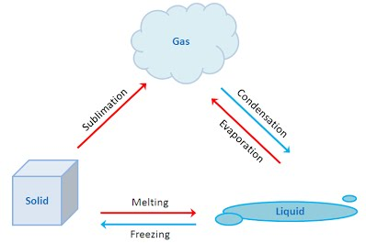
Deposition

Lose Energy:

Freezing: _________________ loses energy to become _________________

Condensation:_______________ loses energy to become ________________

Deposition:__________________ loses energy to become ________________

Gain Energy:

______________: solids gain energy to become liquid

______________: Liquids gain energy to become gas

______________: solids gain energy to become gas

Fluids:
- Of the four naturally occurring states of matter, we will look at two of them; ____________________ and _____________________.
- Combined we refer to these states of matter as "Fluids." A fluid is defined as any substance that is able to flow or will change shape continually under a constant force.

