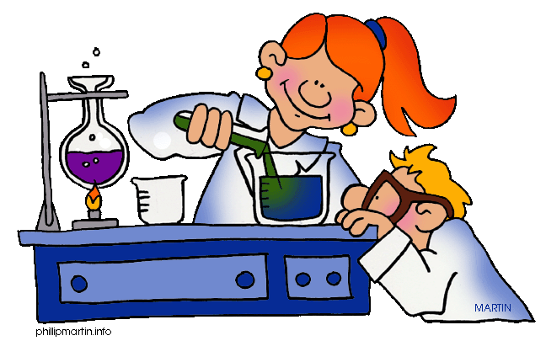

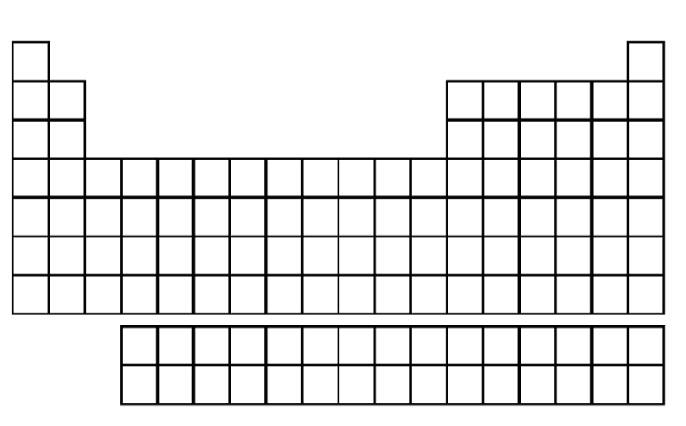

Matter:
Label the following diagrams with the correct phase of matter.
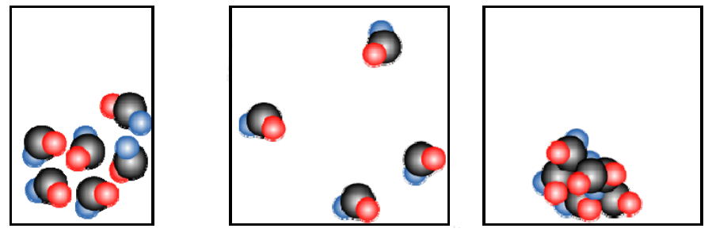
1. _LIQUID_____ 2. ______GAS_____ . ____SOLID______

- Chose the option that describes the following molecules. (307-14)
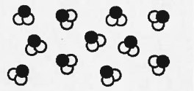
- Compound
- Mixture of compounds
- Mixture of elements
- Mixture of compounds and elements

- Chose the option that describes the following molecules. (307-14)
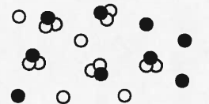
  - Compound
  - Mixture of compounds
  - Mixture of elements
  - Mixture of compounds and elements
- What 2 characteristics does all matter have?

MASS and VOLUME

4) Identify the state(s) of matter described by each statement.
- Has a definite volume- Solid, Liquid
- Has a definite shape- Solid
- Completely fills any container- Gas
- Flows- Liquid, Gas
- Is made of particles held together in a rigid structure- Solid
- Is made of particles that are close together- Solid, Liquid

Chemical and Physical Properties:
1. What is the main difference between physical properties and chemical properties?
a. Chemical properties are cooler than physical properties
b. Chemical properties are observed with the senses, physical properties are observed by changing the substance
c. Physical properties are observed with the senses, chemical properties are observed by changing the substance
d. There is no difference

2. Give two examples of a qualitative physical property and two examples of quantitative physical properties.

Odor, Color, Shape, State of Matter= Qualitative (Uses the 5 senses)
Length, volume, ductility= Quantitative (Uses measurements or numbers)

3. Give one example of a chemical property.

Flammability

4. Circle whether each of the following is a physical change or a chemical change:
a. Tearing a sheet of paper (physical/ Chemical)
b. Melting a piece of wax (Physical/ Chemical)
c. Burning a log (Physical /Chemical )

5. Label the following as a quantitative (N) or qualitative (L) observation by placing an N or L in the blank.
a. The blanket is blue ____L___
b. The window is wide ____L___
c. He’s 5’9” tall ____N____
d. The reaction took 5 seconds ____N____
e. This quiz is cool ___L_______
f. This quiz has 6 questions ___N_____

6. Contrast mixtures with pure substances.

Mixtures are heterogeneous meaning they have at least two different particles and you can see all the particles that are in the mixture (eg: salt and pepper, oil and water)
Pure substances are homogeneous meaning they appear to be only one substance. Pure substances have only ONE UNIQUE type of particle

2 Physical and Chemical Changes
A physical change occurs when the appearance of a substance changes, but chemically the substance is the same. The individual molecules do not change, and no new matter is formed. During some physical changes, matter simply changes from one state to another. Evaporating, melting, freezing, and sublimating are examples of physical changes in which matter changes from one state to another.
Chemical change occurs when a chemical reaction takes place. The substances produced during a chemical reaction are different from the original substances.

Directions: Examine the list of changes below. Write C before each chemical change. Write P before each physical change.
___P__ 1. Erosion of a riverbed by water
___C__ 2. Leaves changing color
___P__ 3. Glass breaking
___P__ 4. Carving a statue out of marble
___C__ 5. A rusting bicycle
___P__ 6. Sanding a piece of wood
___P__ 7. Ice cream melting
___C__ 8. Fireworks exploding
___C__ 9. Baking a cake
___P__ 10. Chocolate melting
___C__ 11. Frying an egg
___P__ 12. Cutting grass
___P__ 13. Water evaporating from a pond
___C__ 14. Vinegar is mixed with baking soda
___C__ 15. Spoiling food
___C__ 16. Burning toast
___P__ 17. Melting butter for popcorn
___C__ 18. Cooking waffles
___C__ 19. Lighting a match
___P__ 20. Mothballs disappear over time
___C__ 21. Plants undergo photosynthesis
___C__ 22. A red mark appears after a bee sting
___C__ 23. A drop of hydrochloric acid on marble produces carbon dioxide gas (bubbles)

30. Explain how aluminum could undergo a physical change? A chemical change?
Physical Change- crumple into a ball (just changing the way it looks)
Chemical change- in our magic show when we added it to Copper Chloride and it rusted/ turned red; or a bike made out of aluminum left in the rain would rust
3. Complete the table
Name of the element | Symbol of the element |  | Name of the element | Symbol of the element
Argon | Ar |  | Calcium | Ca
Carbon | C |  | Copper | Cu
Mendelevium | Md |  | Zinc | Zn
Chromium | Cr |  | Helium | He
Krypton | Kr |  | Mercury | Hg
Oxygen | O |  | Magnesium | Mg

4. Draw the Bohr Model for the following Elements
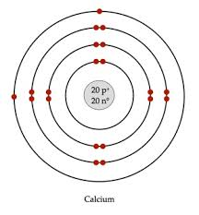
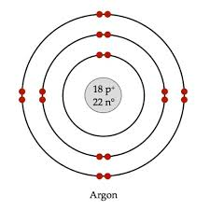
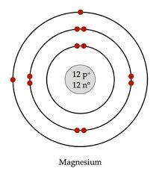

5. Name the elements below using the Bohr Model diagrams.
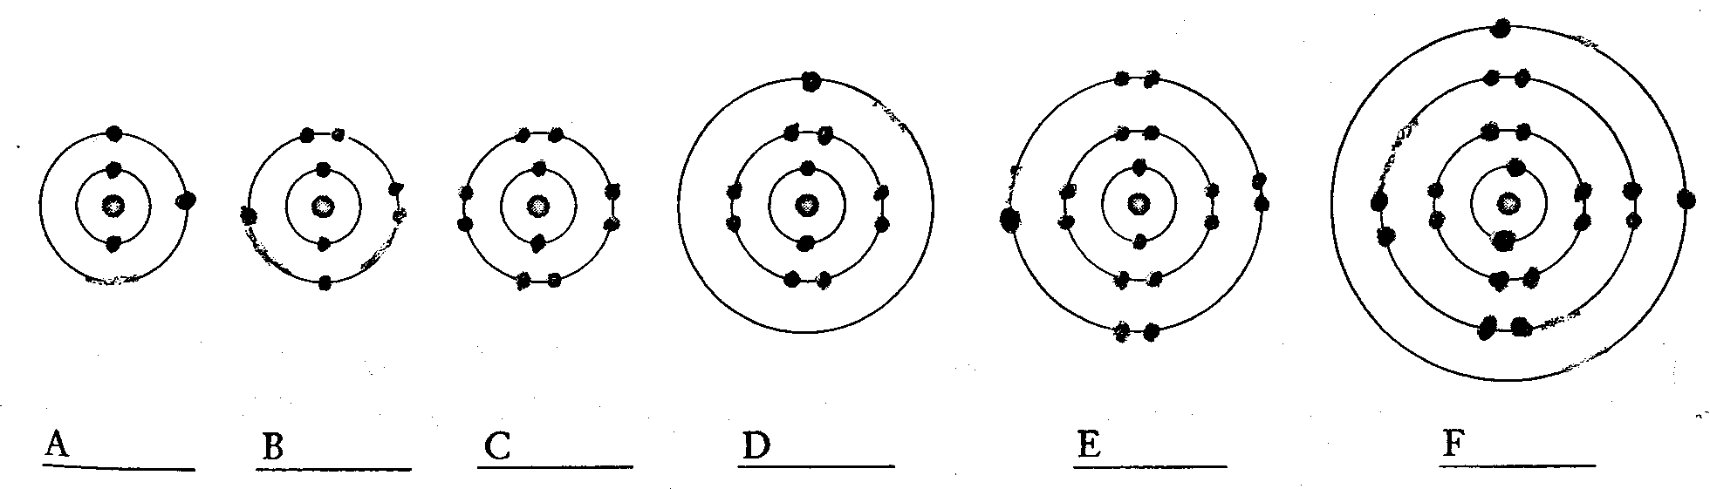
A) Beryllium b) Oxygen C) Neon D) Sodium e) Chlorine f) Calcium

6. Complete the table
Symbol | Element | Atomic number | Atomic mass | Number of protons | Number of electrons | Number of neutrons
Mg | Magnesium | 12 | 24 | 12 | 12 | 24-12=12
Ca | Calcium | 20 | 40 | 20 | 20 | 40-20=20
Be | Beryllium | 4 | 9 | 4 | 4 | 9-4=5
K | Potassium | 19 | 39 | 19 | 19 | 39-19=10
Na | Sodium | 11 | 23 | 11 | 11 | 23-11=12
Li | Lithium | 3 | 7 | 3 | 3 | 7-3=4
P | Phosphorus | 15 | 31 | 15 | 15 | 31-15=16

7. Complete the information below.
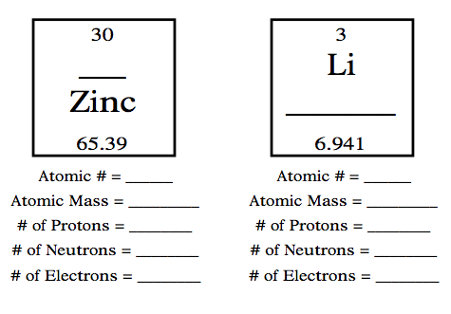
8. Explain the difference between an atomic number and the atomic mass.
Atomic number is always a whole number and it signifies how many PROTONS are found in the nucleus of the element. The atomic mass is usually a decimal; it is the weight of a single atom of the element in atomic mass units- combining the weight of the protons and neutrons. It is a decimal because it is an average of all the isotopes of that particular element (an isotope being atoms of an element with different numbers of neutrons in the nucleus).

9) Label the following on the periodic table below:
(A) Alkali Metals (C) Metalloids (E)Noble Gases (G) Lanthanides
(B) Alkali Earth Metals (D) Halogens (F)Transition Metals (H) Actinides
(I) Where does the table break from metals/metalloids/non-metals?
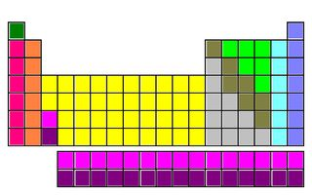

***IF TIME ALLOWS****
9) Fill in the following chart:

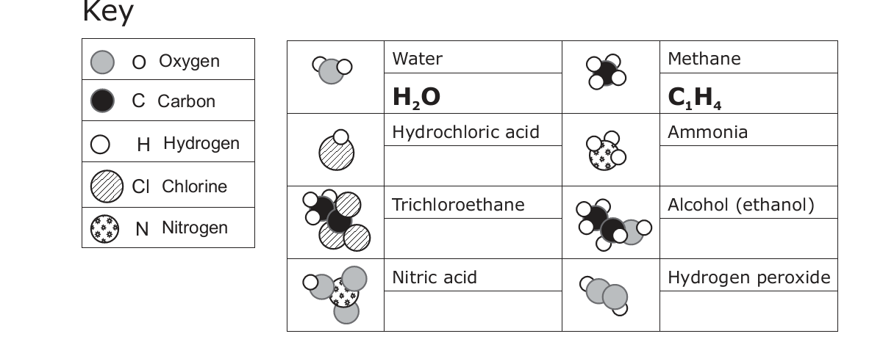

9. Using the illustration:
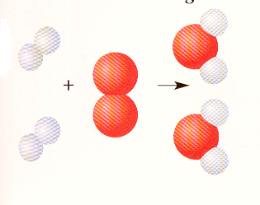
- How many molecules are at the end of this chemical reaction? __________2______________
- If the oxygen atoms are bigger than hydrogen atoms, how many atoms of hydrogen are present at the beginning of this chemical reaction?________________4_______________
- Is an element or compound formed at the end of this chemical reaction?_______compound______
- What is the common name of the molecule that was formed?____Water (H₂O)______

10. Hydrogen is an element in the first group. The low density of hydrogen makes it an ideal substance for weather balloons. However, its properties also make it a poor substance for things like Blimps that carry people. Why?

Hydrogen on it’s own as a gas is extremely flammable and reactive. It would not make a good blimp to carry people because if exposed to heat/flame/spark would ignite blow up! Hydrogen is the MOST reactive element in the periodic table because of it’s lone electron on its valence that is willing to react with almost any other element.

