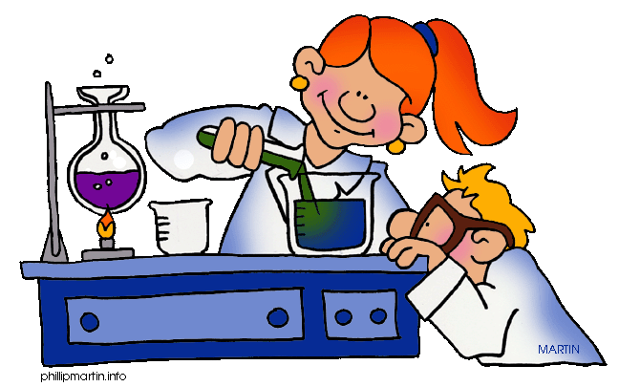

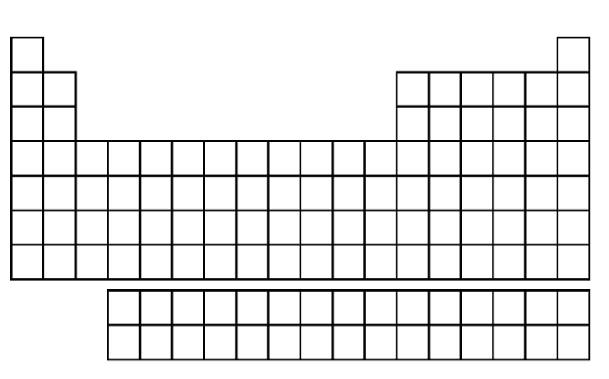

B

Matter:
Label the following diagrams with the correct phase of matter.
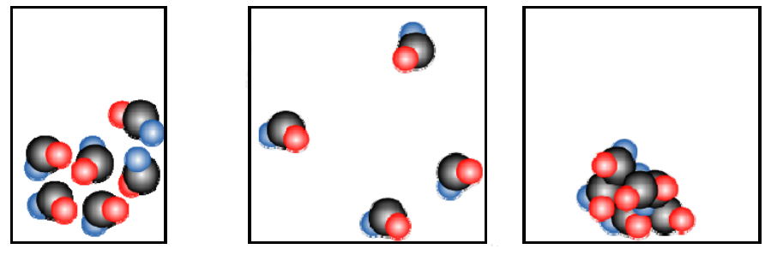
1. ____________ 2. ____________ 3. ___________

- Chose the option that describes the following molecules. (307-14)
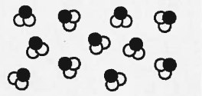
- Compound
- Mixture of compounds
- Mixture of elements
- Mixture of compounds and elements

- Chose the option that describes the following molecules. (307-14)
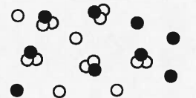
  - Compound
  - Mixture of compounds
  - Mixture of elements
  - Mixture of compounds and elements

- What 2 characteristics does all matter have?

4) Identify the state(s) of matter described by each statement.
- Has a definite volume
- Has a definite shape
- Completely fills any container
- Flows
- Is made of particles held together in a rigid structure
- Is made of particles that are close together

Chemical and Physical Properties:
1. What is the main difference between physical properties and chemical properties?
a. Chemical properties are cooler than physical properties
b. Chemical properties are observed with the senses, physical properties are observed by changing the substance
c. Physical properties are observed with the senses, chemical properties are observed by changing the substance
d. There is no difference

2. Give two examples of qualitative physical properties and two examples of quantitative physical properties.

3. Give one example of a chemical property.

4. Circle whether each of the following is a physical change or a chemical change:
a. Tearing a sheet of paper (physical/ Chemical)
b. Melting a piece of wax (Physical/ Chemical)
c. Burning a log (Physical /Chemical )

5. Label the following as a quantitative (N) or qualitative (L) observation by placing an N or L in the blank.
a. The blanket is blue _______
b. The window is wide _______
c. He’s 5’9” tall ________
d. The reaction took 5 seconds ________
e. This quiz is cool __________
f. This quiz has 6 questions
6. Contrast mixtures with pure substances.

2 Physical and Chemical Changes
A physical change occurs when the appearance of a substance changes, but chemically the substance is the same. The individual molecules do not change, and no new matter is formed. During some physical changes, matter simply changes from one state to another. Evaporating, melting, freezing, and sublimating are examples of physical changes in which matter changes from one state to another.
Chemical change occurs when a chemical reaction takes place. The substances produced during a chemical reaction are different from the original substances.

Directions: Examine the list of changes below. Write C before each chemical change. Write P before each physical change.
_____ 1. Erosion of a riverbed by water
_____ 2. Leaves changing color
_____ 3. Glass breaking
_____ 4. Carving a statue out of marble
_____ 5. A rusting bicycle
_____ 6. Sanding a piece of wood
_____ 7. Ice cream melting
_____ 8. Fireworks exploding
_____ 9. Baking a cake
_____ 10. Chocolate melting
_____ 11. Frying an egg
_____ 12. Cutting grass
_____ 13. Water evaporating from a pond
_____ 14. Vinegar is mixed with baking soda
_____ 15. Spoiling food
_____ 16. Burning toast
_____ 17. Melting butter for popcorn
_____ 18. Cooking waffles
_____ 19. Lighting a match
_____ 20. Mothballs disappear over time
_____ 21. Plants undergo photosynthesis
_____ 22. A red mark appears after a bee sting
_____ 23. A drop of hydrochloric acid on marble produces carbon dioxide gas (bubbles)

30. Explain how aluminum could undergo a physical change? A chemical change?

3. Complete the table
Name of the element | Symbol of the element |  | Name of the element | Symbol of the element
Argon |  |  |  | Ca
Carbon |  |  |  | Cu
Mendelevium |  |  |  | Zn
Chromium |  |  |  | He
Krypton |  |  |  | Hg
Oxygen |  |  |  | Mg

4. Draw the Bohr Model for the following Elements
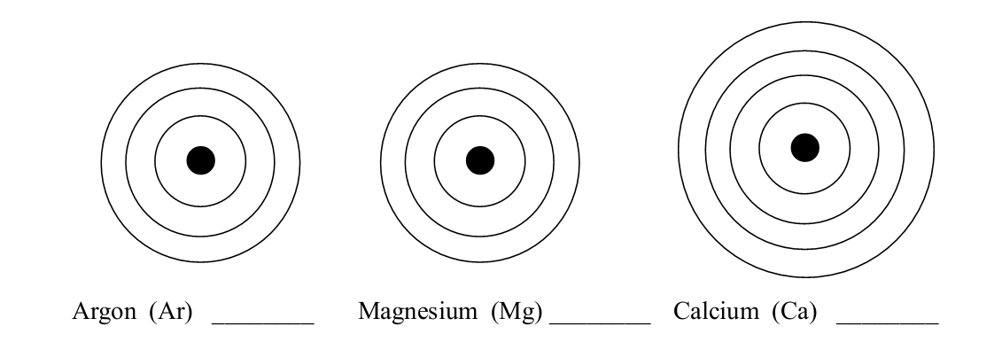
5. Name the elements below using the Bohr Model diagrams.
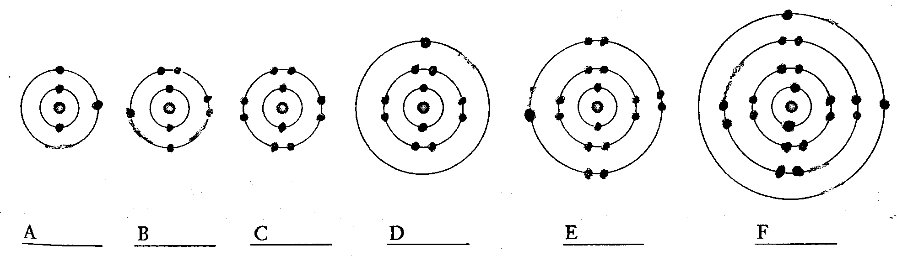

6. Complete the table
Symbol | Element | Atomic number | Atomic mass | Number of protons | Number of electrons | Number of neutrons
Mg
Ca
Be
K
Na
Li
P

7. Complete the information below. *********
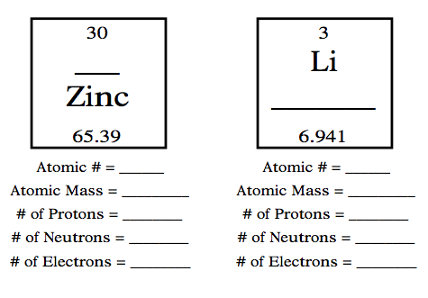
8. Explain the difference between an atomic number and the atomic mass.

9) Label the following on the periodic table below:
(A) Alkali Metals (C) Metalloids (E)Noble Gases (G) Lanthanides
(B) Alkali Earth Metals (D) Halogens (F)Transition Metals (H) Actinides
(I) Where does the table break from metals/metalloids/non-metals?
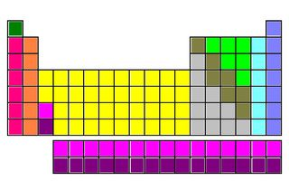

***IF TIME ALLOWS****
9) Fill in the following chart:

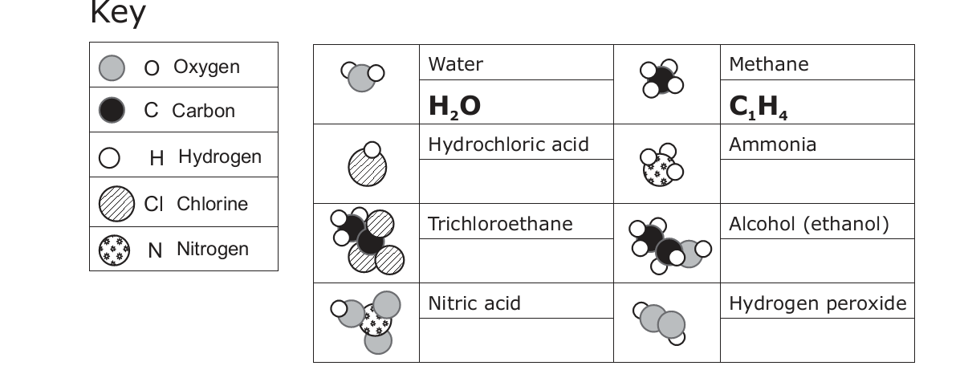

9. Using the illustration:
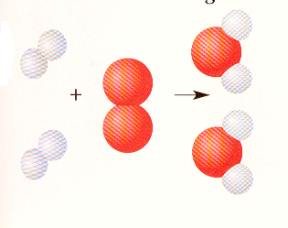
- How many molecules are at the end of this chemical reaction? ________________________
- If the oxygen atoms are bigger than hydrogen atoms, how many atoms of hydrogen are present at the beginning of this chemical reaction?_______________________________
- Is an element or compound formed at the end of this chemical reaction?_____________
- What is the common name of the molecule that was formed?__________

10. Hydrogen is an element in the first group. The low density of hydrogen makes it an ideal substance for weather balloons. However, its properties also make it a poor substance for things like Blimps that carry people. Why?


