Electromagnetic Spectrum
Light:
- Light is a form of energy that is visible to the human eye.
- Light is __________________________________________________ that is visible to the human eye.
- There are many types of electromagnetic energy (light) but they all travel as waves at the speed of light.
- All of the different types of light are arranged in the electromagnetic spectrum.

Electromagnetic Spectrum
- These are the different kinds of_____________________________
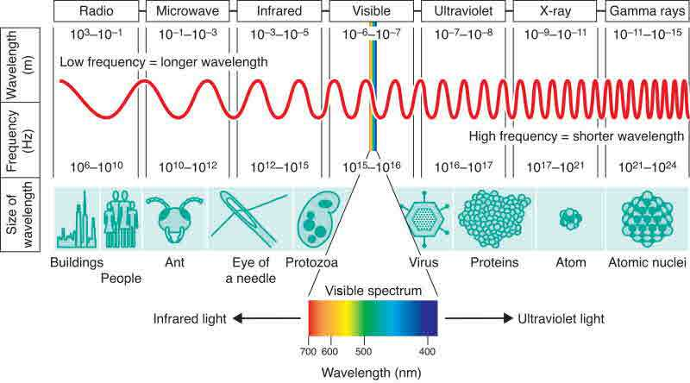
- All electromagnetic energy travels in ____________________________
- __________________ – the distance from one crest to the next crest (or one trough to the next trough)
- The _______________________ is the number of waves that pass a point in one second (or a given unit of time)
- Frequency is given in units called ______________________________
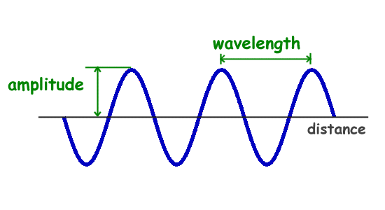
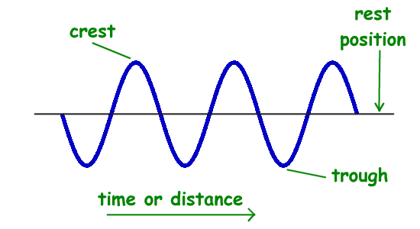

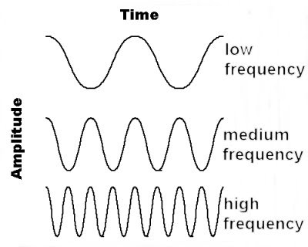
Which colour has:

- 1. The longest wavelength?_______________________________
- 2. The highest frequency?________________________________
- 3. The shortest wavelength?______________________________
- 4. The lowest frequency?_________________________________

