Mass, Volume and Density Notes

Coke Can Experiment:
In your own words, explain what happened when you watched the Diet Coke and regular Coke being placed in a container of water. Explain WHY!
________________________________________________________________
________________________________________________________________
________________________________________________________________
________________________________________________________________

Mass:
- Measurement of the amount of ____________________(or stuff) in an object
  - Measured in _________________ (g)

Volume:
- Measurement of the amount of _______________ an object takes up
  - Measured in ________________(ml) or __________ _________________ cm³

1Kg of Feathers or 1Kg of Rocks: Which do you think would have the greater volume? The greater mass? Why?
________________________________________________________________
________________________________________________________________
________________________________________________________________
________________________________________________________________

Density:
- Density is defined as _________________________________________.
- It is a measure of how ______________________________ and how heavy the molecules are in an object.
- Density is the amount of ______________within a certain _________________.

Practice:
- Which is more dense? Box A or Box B
Why?
________________________________________________________________
________________________________________________________________

- Which is more dense? Box A or Box B
Why?
________________________________________________________________
________________________________________________________________

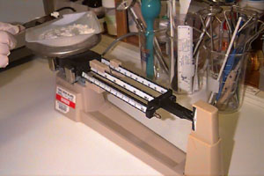
Finding Density:
1) Find the mass of the object
2) Find the volume of the object
3) Divide
Density = Mass g
Volume cm³
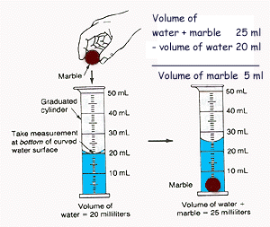
Displacement Method:
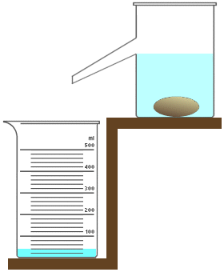
- Awkward Sized item with a difficult volume to solve for?
- Any object displaces a volume of water equal to it’s own volume when placed in water.

Density Practice Questions:
To find density:
- Find the mass of the object
- Find the volume of the object
- Divide : Density = Mass ÷ Volume

Example:
If the mass of an object is 35 grams and it takes up 7 cm³ of space, calculate the density.
Set up your density problems like this:
Given: Mass = 35 grams Volume = 7 cm³ Unknown: Density (g/ cm³)
Formula: D = M / V
Solution: D = 35g/7 cm3
D = 5 g/cm3

1 Frank has a paper clip. It has a mass of 9g and a volume of 3cm³. What is its density?

2. Frank also has an eraser. It has a mass of 3g, and a volume of 1cm³. What is its density?

3. Jack has a rock. The rock has a mass of 6g and a volume of 3cm³. What is the density of the rock?

4. Jill has a gel pen. The gel pen has a mass of 8g and a volume of 2cm³. What is the density of the rock?

