**LAB J: 2.3 Reflecting Light with Curved Mirrors**  NAME:_____________________

1. A mirror that is curved inwards like a bowl is called a ________________ mirror.
2. Look at the inside of a spoon. Describe what you see.
3. Look at the concave mirror supplied. What does the reflection look like?
4. What happens when you move far away from the mirror?
5. What happens when you are very close to the mirror?
6. Turn on the light source and sketch a ray diagram of a concave mirror as the light source hitting it. Page 197. Note that the rays follow the Law of Reflection!

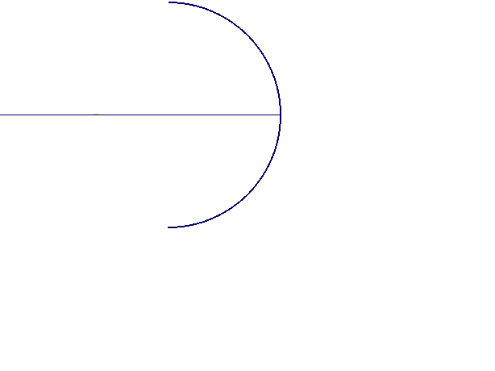

1. The place where the light rays all head to a common point is called the __________________ __________________.
2. Because of the shape of a concave mirror they are very good at ___________ ____________ and ________________ it to a ______________ __________________.
3. Explain where concave mirrors are used and why.

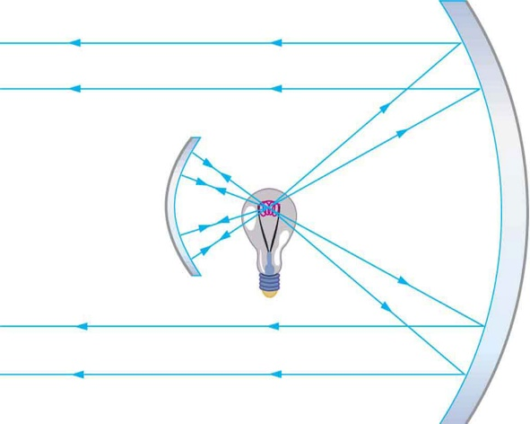

1. Look at the ray diagram of a flashlight or car headlight. Which way are the rays of light going? Why?

Why do you think headlights or flashlights are designed this way?

1. Explain what an image looks when the object is outside the focal point and

what happens as the object approaches the focal point.

1. When using a concave mirror, explain when you get an image that is upright

and enlarged?

**LAB K: REFLECTING LIGHT WITH CURVED MIRRORS:** (page 199)

1. A mirror with the surface curved outwards is called a ____________ ________.

2. Look at the outside of a spoon. Describe what you see.

3. Look at the convex mirror supplied. What happens when you move far away from

the mirror?

4. What happens when you move very close to the mirror?

5. Turn on the light source and sketch a ray diagram of a convex mirror that has a light

source hitting it. Page 199. Note that the rays follow the Law of Reflection!

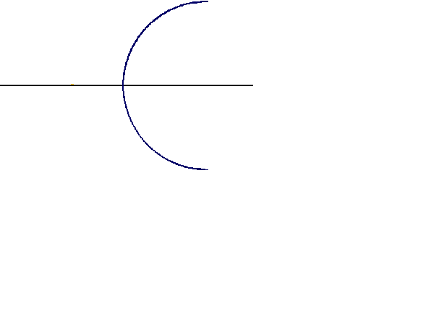

6. Describe what type of image you get when using a convex mirror.

7. List a couple of places where convex mirrors are used.

8. What warning message do some convex mirrors have on them?