Name:__________________________________ Class:____________
TRY LOOKING AT THE LARGE CONCAVE AND CONVEX MIRRORS

a) Which mirror gives you a large viewing area? ____________________

b) Which mirrors gives you a large image? ________________________ Explain where
you need to be in relationship to the mirror to get the large image.

c) Identify the type of mirror used in each case below: FLAT, CONCAVE, CONVEX.
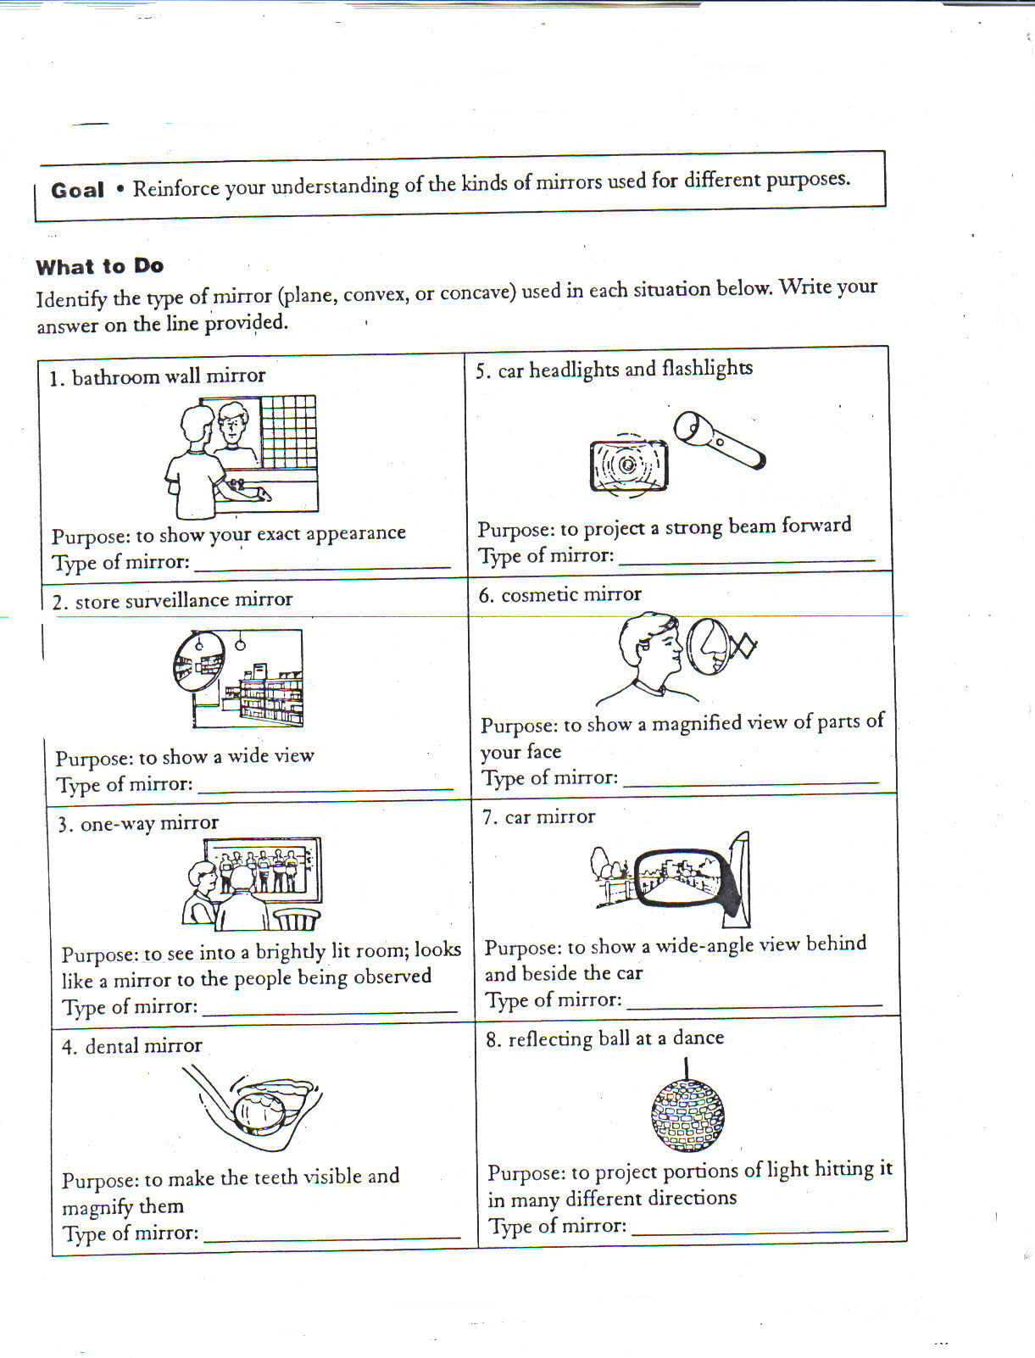
Write the type of mirror on the line below each situation.

