**Density & Buoyancy**

**Buoyancy:**

* ________________________________________= the ability to float in a fluid.
  + Examples of fluids = water, air
* _______________________________________ = the upward force that acts on a submerged object.
  + It acts opposite of _________________________

Why does the rock sink in water?

_______________________________________________________________________________________________________________________________________________________________________________________________________________________________________________________________________________________________________________

Why is it easier to lift a rock in water than it is on land?

_______________________________________________________________________________________________________________________________________________________________________________________________________________________________________________________________________________________________________________

Why does the beach ball float?

_______________________________________________________________________________________________________________________________________________________________________________________________________________________________________________________________________________________________________________

**Archimede’s Principle:**

* ___________________________ _______________________: The buoyant force acting on a submerged object is equal to the weight of the fluid the object displaces.
* ARCHIMEDES’ PRINCIPLE states that the ________________________________ of the amount of water displaced is equal to the ____________________________________.



Which is more likely to float? A or B

_______________________________________________________________________________________________________________________________________________________________________________________________________________________________________________________________________________________________________________

**Density:**

DOESN’T DENSITY HAVE SOMETHING TO DO WITH IF SOMETHING SINKS OR FLOATS?

d = _____________ / ________________________

DENSITY OF WATER = 1 g/cm3

* If the object has a ________________________________, It _________________________.
* If the object has a ________________________________, It _________________________.
* if the object has the ________________________________, It ______________. (floats in the middle of the water).

Examples:

* Having a _______________________________________ than water means that the beach ball’s _______________________ is______________________ than the ___________________ of the beach ball. SO THE BEACH BALL ______________________________.
* Having a _____________________________________ than water means that the cinder block’s ___________________ is _______________________ than the ______________________of the cinder block. SO THE CINDER BLOCK ____________________________
* Having the ___________________________________ as water means that the boot’s _______________________ is ______________________________ to the ________________________ of the boot. SO THE BOOT NEITHER SINKS NOR FLOATS, IT **________________________________**

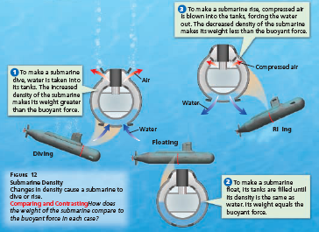**Changing Density**

* You can change an object’s density by:

1. Increasing its mass, _____________________ its density
2. Decrease its mass, ___________________________ its density.
3. Increasing its volume, which _____________________ its density.
4. Decrease its volume, which _____________________ its density.

**Objects Float because….**

* Weight is ___________________ than the buoyant force.
* Object is ___________________________ than the fluid
* Object ________________________________ its mass and becomes less dense than the fluid.
* Object ________________________________ its volume and becomes less dense than the fluid.

**Objects Sink because…**

* Weight is ____________________than the buoyant force.
* Object is _____________________________ than the fluid
* Object ______________________its mass and becomes denser than the fluid.
* Object ______________________its volume and becomes denser than the fluid.