Archimedes Principle and Buoyancy

Name ________________________ Partner’s Name _____________________

Method 1
Step 1 – Find the mass of the weight you have as accurately as possible by hanging the weight from the spring scale. (Try not to be too shaky) Write the mass in Box A below.

Step 2 – With the weight hanging from the spring scale, place the weight in the overflow can. What does it weigh in the water? Write this number in Box B below. Complete your subtraction to get the buoyant force (Box C).

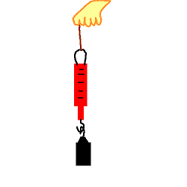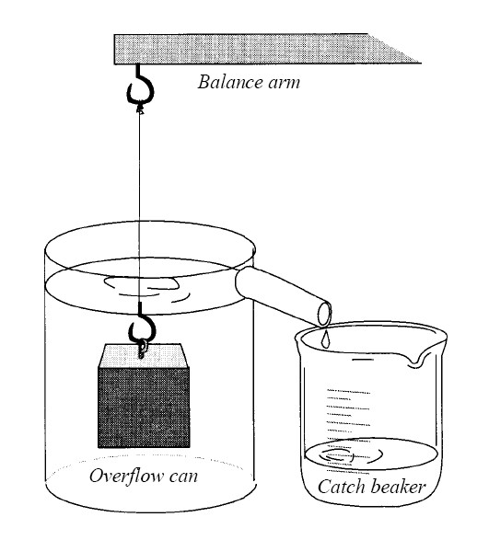

Starting Weight Underwater weight the Buoyant Force
Box A - Box B = Box C

Method 2
Step 3 – Find the mass of your empty graduated cylinder. Write this number in Box Y.

Step 4- Collect the water that was displaced from the overflow can in step 2 and pour it into your graduated cylinder.

Step 4- Find the mass of your graduated cylinder WITH the overflow water in it. Write this number in Box X. Complete your subtraction to get the buoyant force (Box Z).

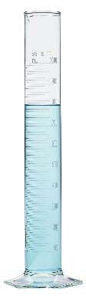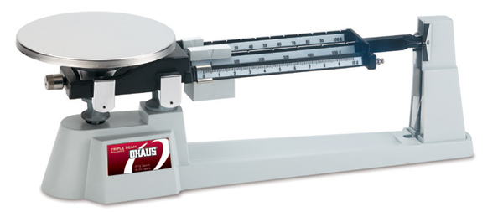

Grad. Cylinder with water Mass of empty grad. cylinder the Buoyant Force
Box X - Box Y = Box Z

Hint: Since 1ml of water = 1 g of water, the buoyant force you find in Box Z should be very close to the volume in your graduated cylinder. If it is not, please raise your hand for a teacher check.

Compare the number in Box Z to the number in Box C – what do you notice? Which is a more accurate measurement?
_________________________________________________________________________________________________________________________________________________________________________________________________________

